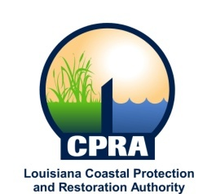

2016 Public Meetings

Johnny Bradberry, Chairman of the Coastal Protection and Restoration Authority, and Executive Assistant to Governor Bobby Jindal for Coastal Activities has announced the public meetings schedule for the Governor’s Advisory Commission on Coastal Protection, Restoration and Conservation. Details on the meetings will be sent out at a later date. The dates and locations of these meetings are subject to change

Governor’s Advisory Commission

February 17, 2016
Algiers, LA

May 25, 2016
Baton Rouge, LA

August 3, 2016
Algiers, LA

October 5, 2016
Baton Rouge, LA

